**TASK-03**

Body Mass Index

**EXPLANATION:**

The program asks the user to enter his / her body weight in pounds and body height in inches and then calculates the Body Mass Index of the person.

Where BMI tells weather, the person is healthy weight or under-weight or over-weight. The program also shows the BMI of the person.

**INPUT:**

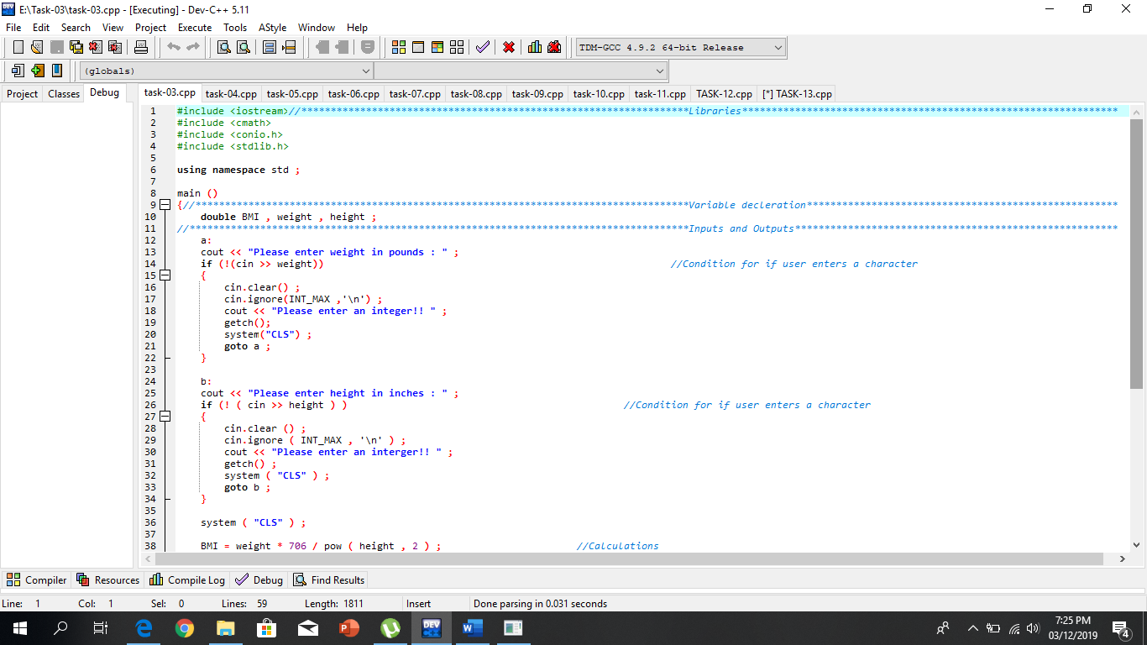

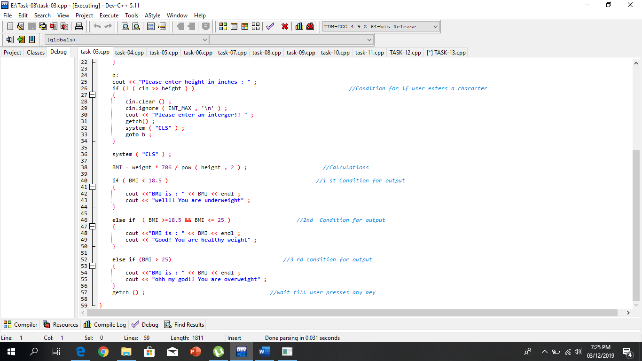

**OUTPUT:**

